Practical No. 4
Aim : 6) WAP that takes the marks of 5 subjects and displays the grades.

Name : Danish Altaf Solkar | Class : CO - B
Enrolment no. : 24111590805 | Batch : 2

Code :-
m1=float(input("Enter marks of 1st subject : "))
m2=float(input("Enter marks of 2nd subject : "))
m3=float(input("Enter marks of 3rd subject : "))
m4=float(input("Enter marks of 4th subject : "))
m5=float(input("Enter marks of 5th subject : "))
total=m1+m2+m3+m4+m5
percentage=total/5
print("Total marks : ",total)
print("Percentage : ",percentage)

OUTPUT :-
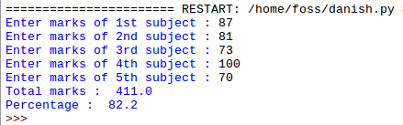

Process related  (30) | Product related  (20) | Total Marks  (50) | Signature

